Testing Dremio – Oracle integration

# Query pushdown:

Created EMPLOYEES_EXT table with 1M rows.

## Query the full table:

SELECT * FROM EMPLOYEES_EXT

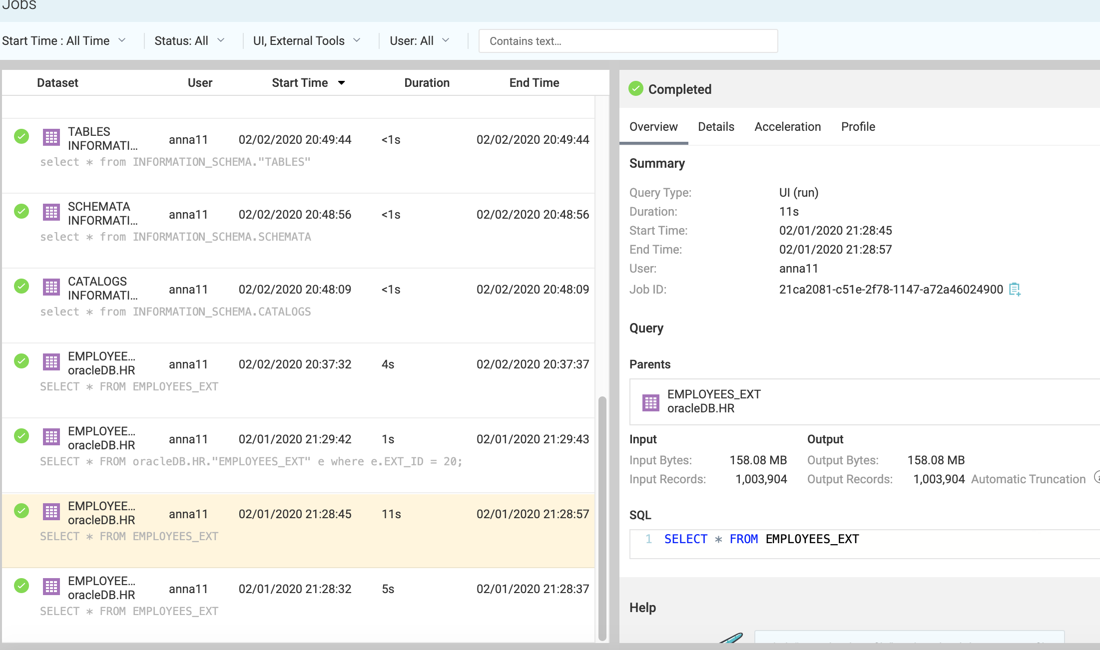

## Preview Query:

SELECT * FROM EMPLOYEES_EXT

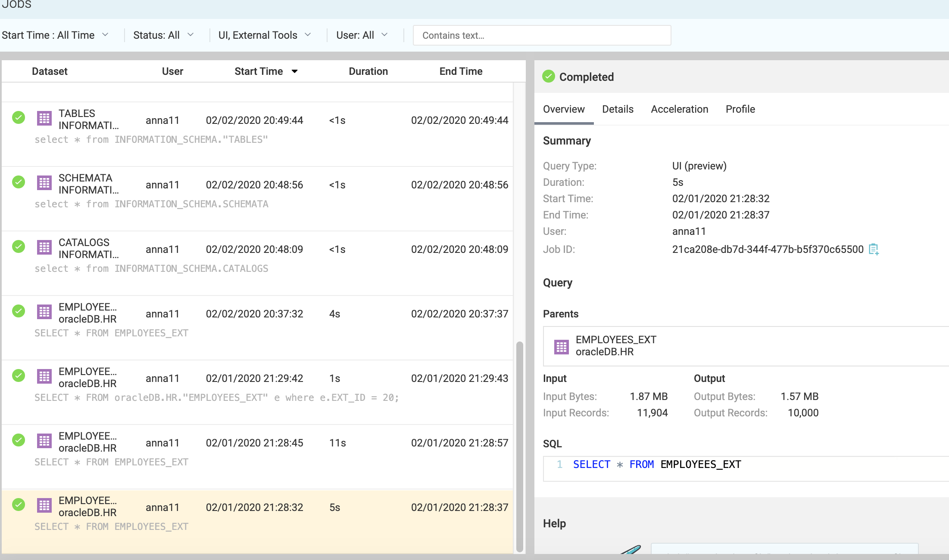

## Filtered quiery (Pushdown has been applied):

SELECT * FROM oracleDB.HR."EMPLOYEES_EXT" e where e.EXT_ID = 20;

